

MES’s

ABASAHEB GARWARE COLLEGE

(Autonomous)

|  |  |
| --- | --- |
| NAME | ROLL NO |
| SUSHANT CHAVAN | 16593 |
| HEMANT KSHIRSAGAR | 16595 |
| ARYAN MEDHE | 16650 |
|  |  |

SEM II (2024-2025)

A PROJECT REPORT ON

**ApptitudeAce - A Quiz App**

SUBMITTED BY:-

**Acknowledgement**

We would like to express our sincere gratitude to everyone who supported and guided us throughout the successful completion of our Android Quiz App project using Java.

First and foremost, we are deeply thankful to our project mentor, Pooja Kamthe, for her continuous support, expert guidance, and valuable insights that helped us bring this project to life.

We would also like to thank our friends who took the time to test our application and provided helpful feedback for improvement.

Lastly, we extend our heartfelt appreciation to our families for their constant encouragement and support throughout this journey.

This project has been a rewarding team effort, allowing us to grow both technically and collaboratively.

INDEX

|  |  |
| --- | --- |
| Sr. No. | Name Of Topic |
| 1 | Acknowledgement |
| 2 | Introduction |
| 3 | Existing System |
| 4 | Scope of the system |
| 5 | Feature of the system |
| 6 | System Requirement |
| 7 | Feasibility Study |
| 8 | Analysis and Design |
| 9 | Data Dictionary |
| 10 | Input-Output screen |
| 11 | Limitations / Drawbacks |
| 12 | Future Enhancement |
| 13 | Bibliography |

**Introduction**

In the competitive world of IT and software placements, aptitude tests play a vital role in assessing a student's logical reasoning, problem-solving, and analytical abilities. These tests are often a part of the recruitment process in major IT companies.

To support students in their preparation, our team developed an Android-based Quiz App using Java that allows students-especially from Computer Science and IT backgrounds-to practice aptitude questions efficiently. The application is designed to be lightweight, mobile-friendly, and intuitive.

The project leverages **Java** for backend logic and **XML** for designing the user interface within the **Android Studio** development environment. Key features include a start quiz button, multiple-choice questions, a scoring system, and a summary of results at the end of the quiz.

Through this project, we aimed to enhance our understanding of Android app development, object-oriented programming concepts in Java, and the design of user-friendly interfaces. The Quiz App is designed to be lightweight, efficient, and scalable for future enhancements, such as adding more quiz categories, integrating a database, or enabling user login and score tracking.

**Existing System**

In the current scenario, students preparing for aptitude tests often use traditional methods such as:

* Paperback books (e.g., R.S. Aggarwal)
* Online websites (e.g., IndiaBix, GeeksforGeeks)
* General-purpose quiz or learning apps

However, these systems have several limitations:

* Lack of a **mobile-first approach**, which limits on-the-go learning.
* No real-time performance tracking or feedback.
* Limited offline accessibility.
* Inconsistent user interface and sometimes overwhelming with too much data.

Our project aims to overcome these shortcomings by providing an interactive, mobile-friendly, and focused learning platform.

**Scope of the system**

The primary goal of this system is to empower students with an efficient and accessible tool for aptitude preparation, especially tailored for Computer Science and IT students aiming for placement in reputed IT companies.

The scope includes:

* Login and authentication functionality to maintain user records.
* Storage and retrieval of user attempts and scores.
* A dynamic quiz system with scoring and result tracking.
* Potential future integration of mock interviews, coding challenges, group discussions, and placement tips.
* A user-friendly interface for navigating and attempting quizzes.
* Multiple-choice questions with single-answer selection.
* Easy scalability to add more questions or categories in the future

The system is scalable and can be easily modified to accommodate additional features or serve students from other disciplines.

This project primarily targets users who need a lightweight and accessible tool for learning, self-assessment, or practice. It can be useful for students, teachers, or anyone interested in testing general knowledge through an easy-to-use mobile application.

**Features of the system**

The app includes the following features in its current version:

1. **User Authentication**: Firebase based Secure login and sign-up system to store user data and scores.
2. **Timed Aptitude Quizzes**: Tests designed to simulate real placement test pressure.
3. **Multiple-Choice Questions**: Covering reasoning, quantitative, and verbal aptitude.
4. **Performance Tracking**: Shows the number of correct/incorrect answers and total score.
5. **Interactive and Clean UI**: Designed using modern Android principles with a smooth user experience.

Planned Features for Next Version:

1. **Company-Wise Test Categories**: Users will be able to select a company and attempt tests matching its pattern.
2. **Progress Comparison by Company**: Track performance per company.
3. **Leaderboard with Filters**: Show rankings based on company quizzes.

**System Requirements**

The Android Quiz App requires specific hardware and software configurations for both development and usage. This section outlines the minimum and recommended system requirements.

**1. Development Environment Requirements**

**Hardware Requirements:**

* Processor: Intel Core i3 or higher
* RAM: Minimum 4 GB (8 GB recommended)
* Hard Disk: Minimum 500 MB of free space
* Display: 1024x768 resolution or higher

**Software Requirements:**

* Operating System: Windows 10 / 11, macOS, or Linux
* IDE: Android Studio (latest stable version)
* Programming Language: Java
* Android SDK: API Level 21 (Lollipop) or higher
* Java Development Kit (JDK): Version 8 or above
* Internet connection for downloading dependencies and testing online features

**2. End-User (Mobile Device) Requirements**

**Hardware Requirements:**

* Android smartphone or tablet
* RAM: Minimum 1 GB
* Storage: At least 50 MB of free space
* Screen: Minimum 4-inch display

**Software Requirements:**

* Android OS: Version 5.0 (Lollipop) or higher
* **Internet Connection Required** to fetch quiz data and interact with the app content

**Feasibility Study**

* **Technical Feasibility**:

The application has been built using Java and Android SDK, which are robust and well-documented technologies. Firebase offers secure and scalable backend services that support authentication, data storage, and analytics. Future enhancements such as company-wise features can be smoothly integrated.

* **Economic Feasibility**:

The app is cost-effective as all core tools used are open-source or free. Firebase's free tier is sufficient for small to mid-scale usage. No significant monetary investment is required for app development or hosting.

* **Operational Feasibility**:

The app is highly usable and tailored to students. It requires no technical knowledge to operate. The Ul is simple and minimalistic, ensuring ease of navigation. The upcoming update with more features will improve engagement while keeping usability high.

**Analysis and Design**

1. ER Diagrams

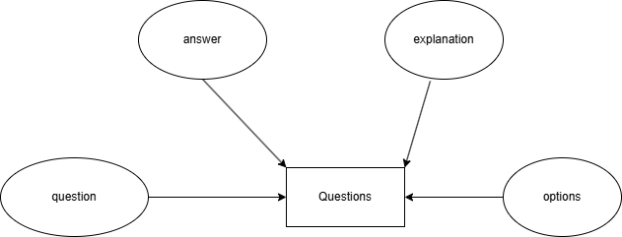

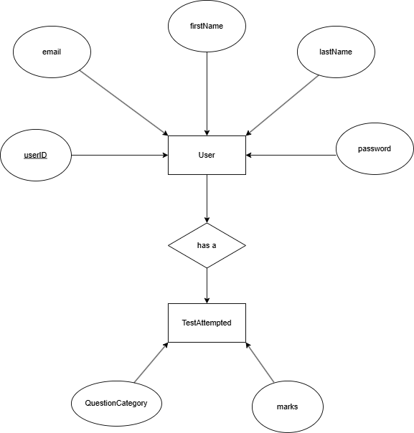

2. Activity Diagram

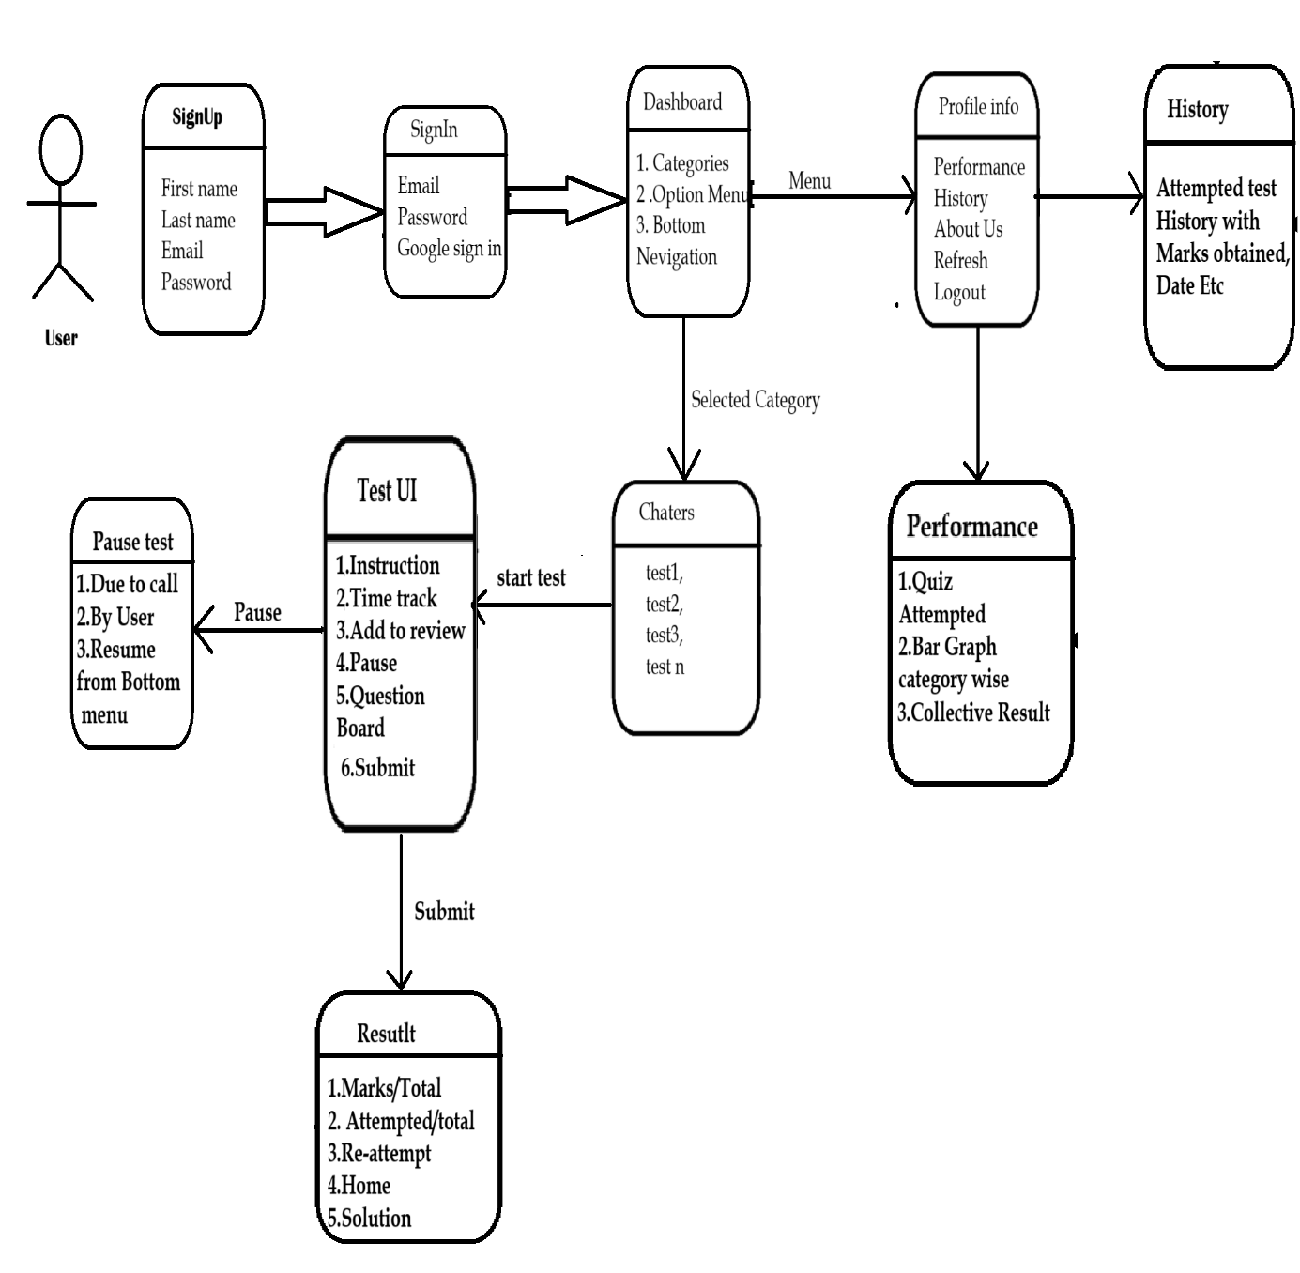

3. Use Case diagram

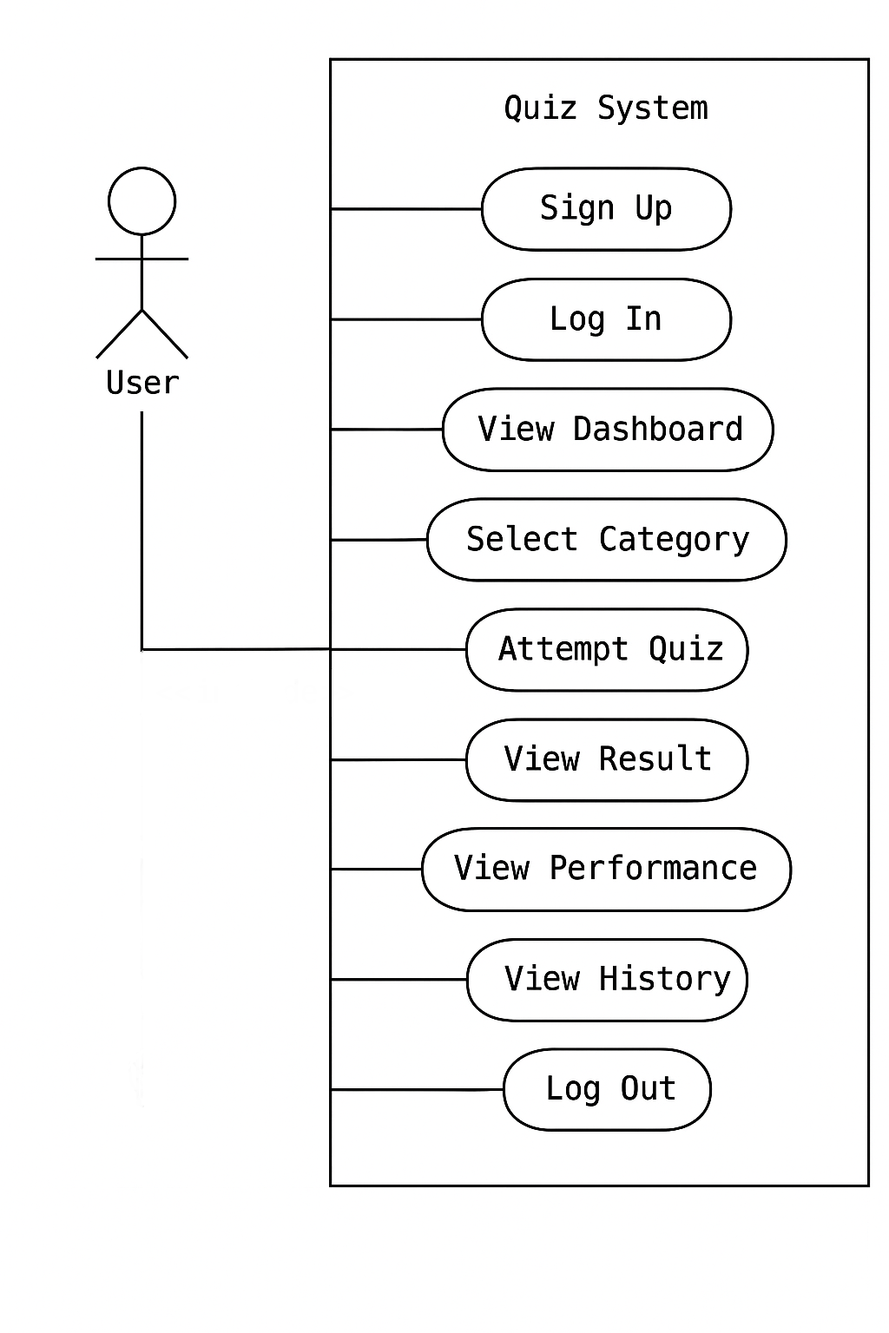

1. Interaction Overview Diagram

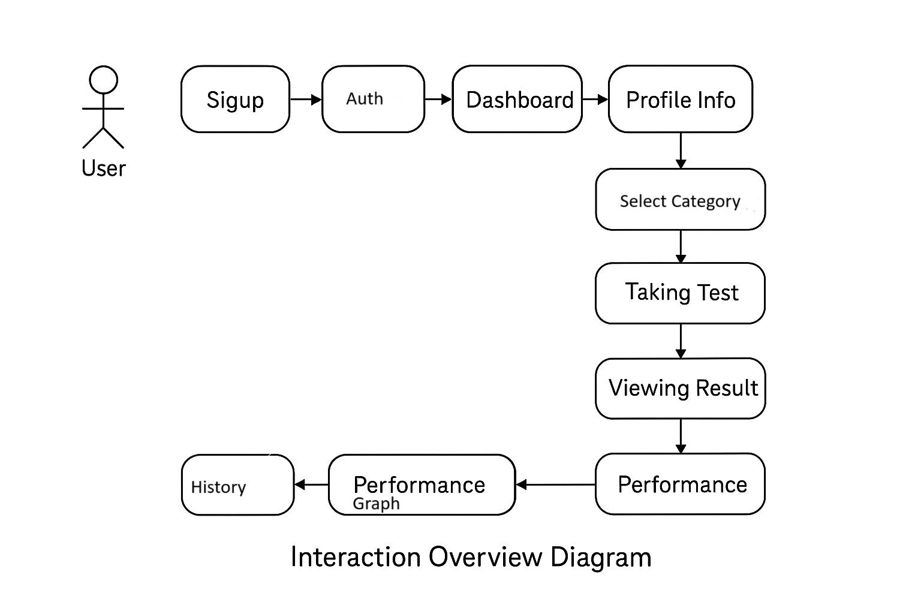

**Data Dictionary**

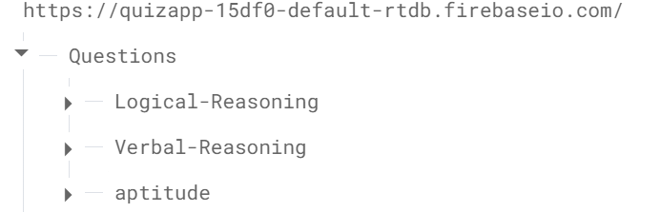

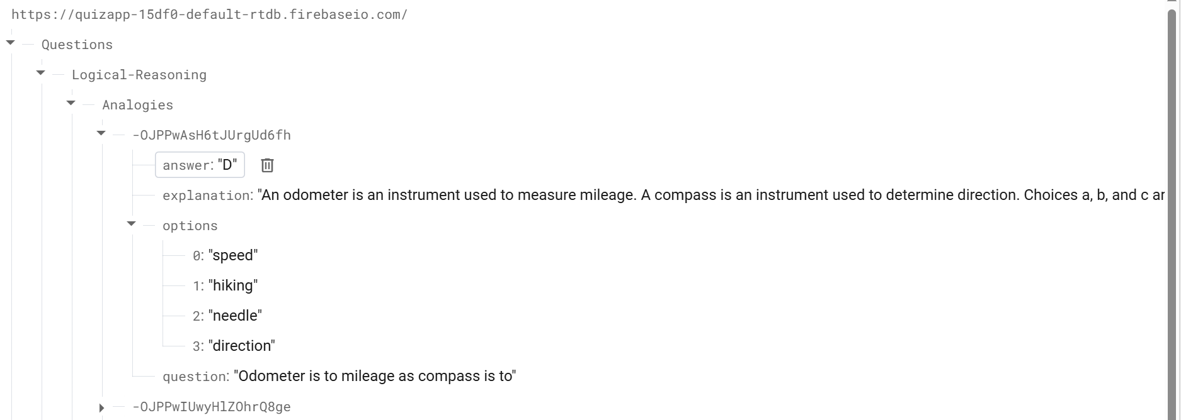

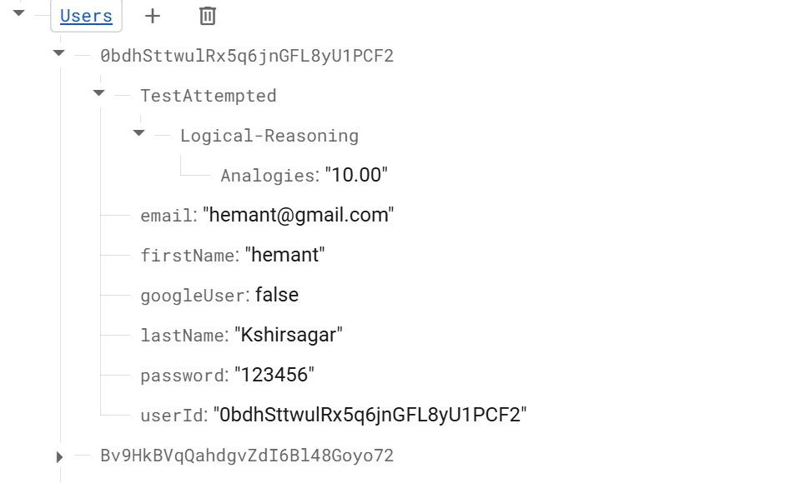

**Input-Output Screen**

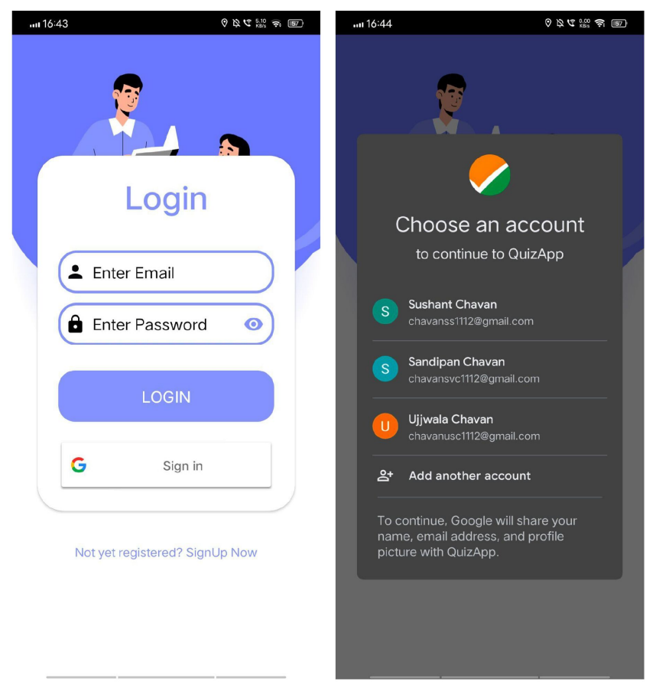

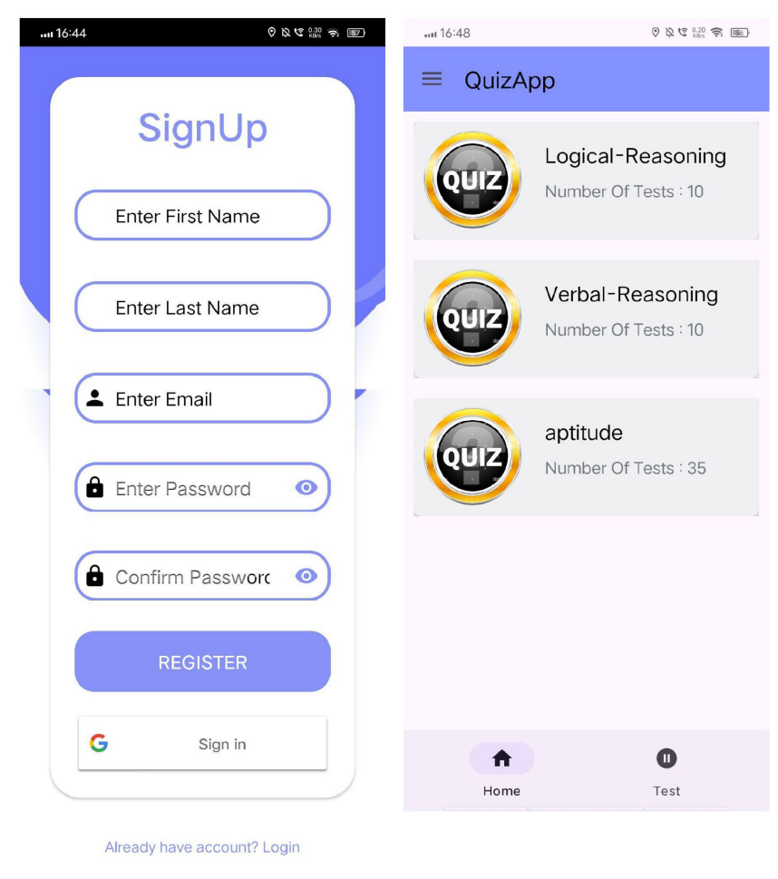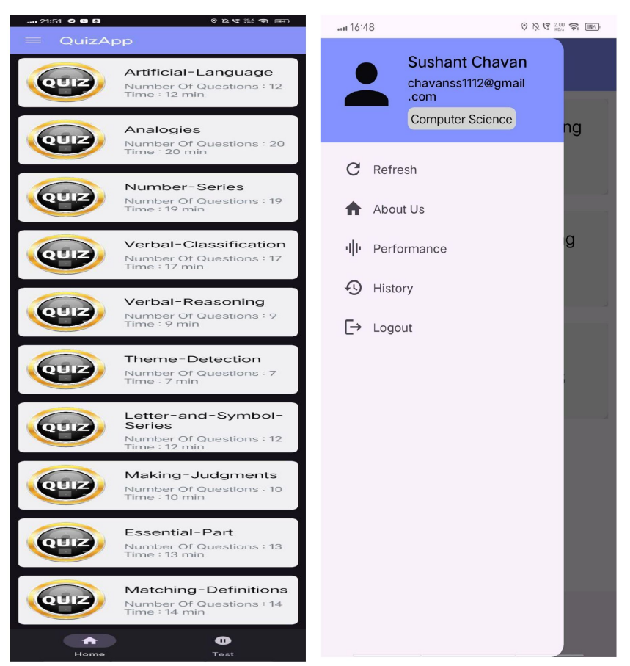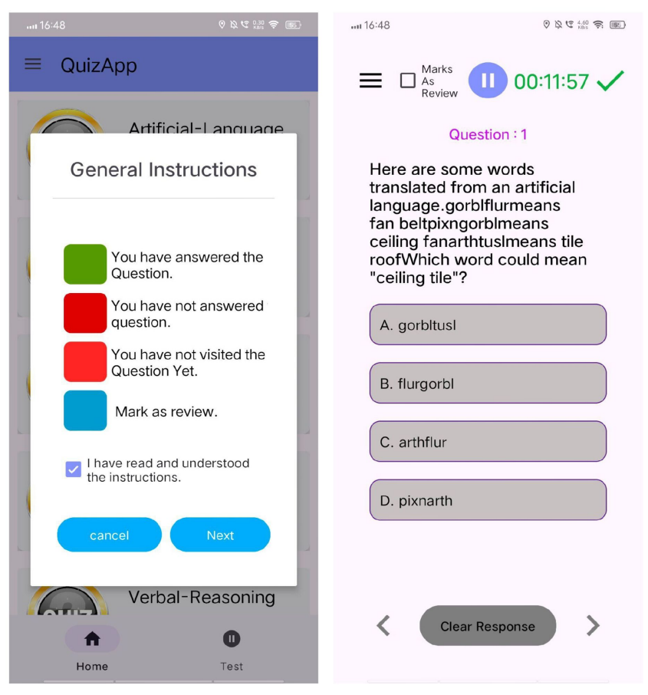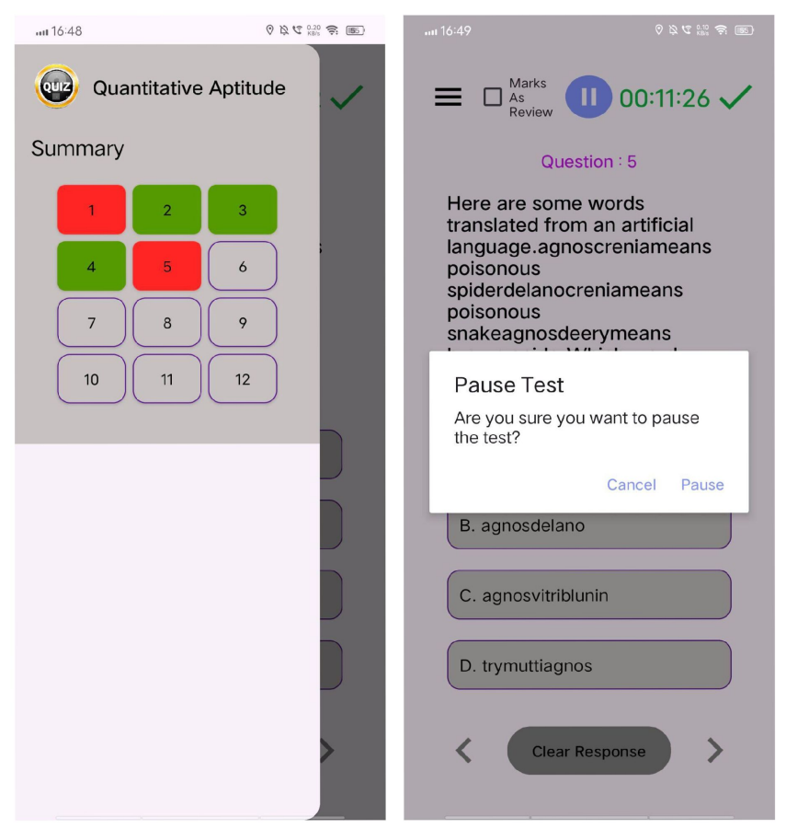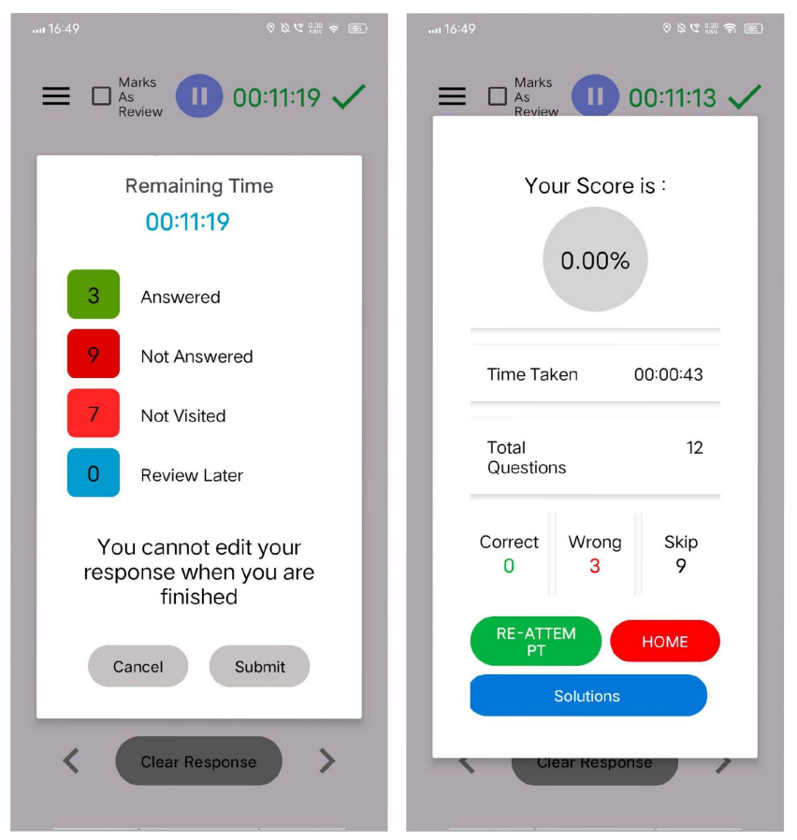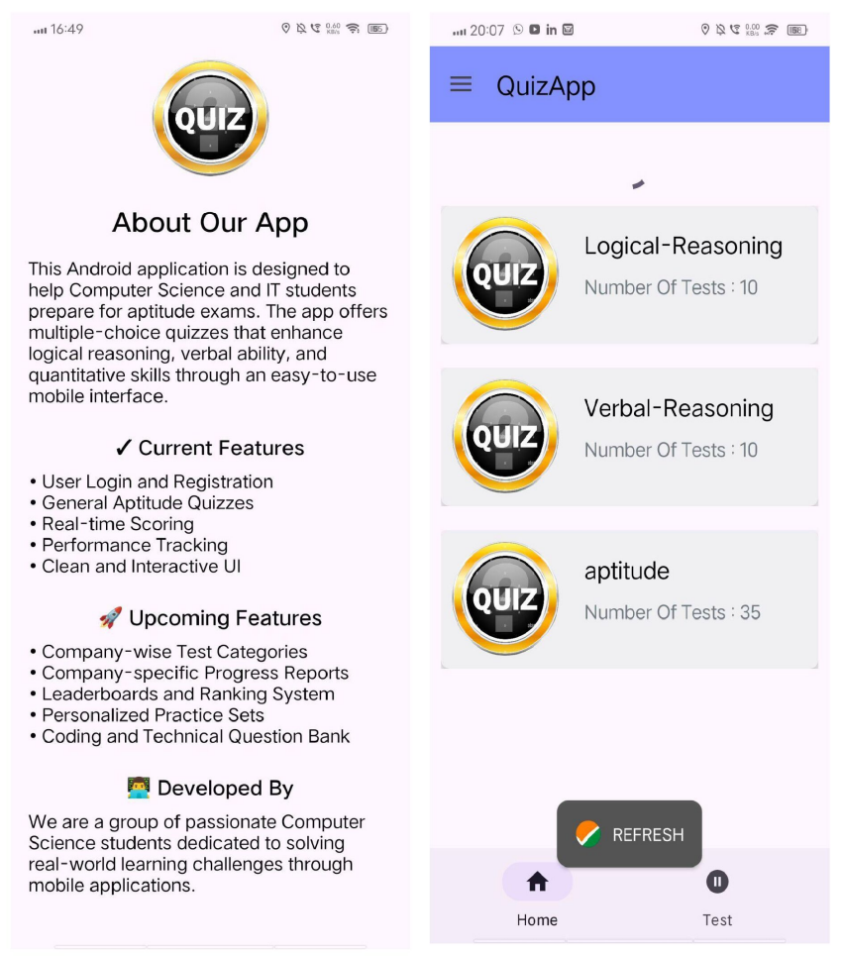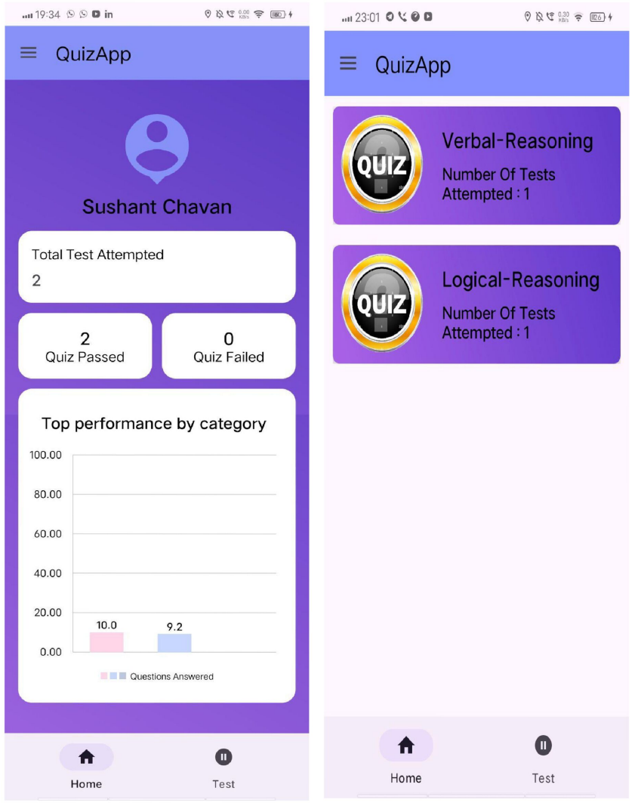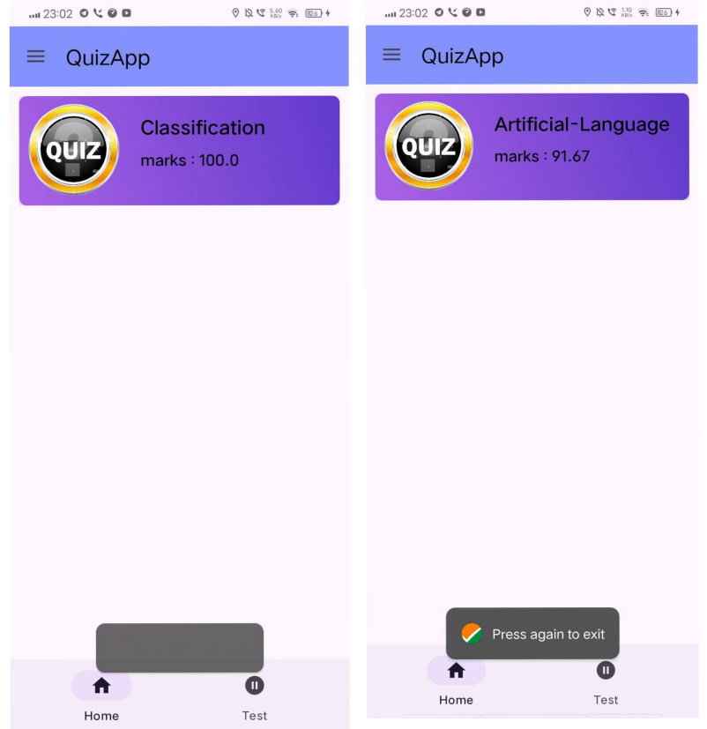

**Limitations / Drawbacks**

* Dependency on external sources (like Indiabix) for questions.
* Scraping limitations due to possible changes in external websites.
* Device compatibility issues across various Android versions and screen sizes.
* Platform limitation - currently available only on Android, excluding iOS, web, and desktop platforms.
* Currently, the app supports only **multiple-choice questions**.
* There is scope for improving the **visual design** and **user experience**, such as adding animations, dark mode, or accessibility features.

**Future Enhancements**

**Improved UI/UX**

* Create a more interactive and modern user experience.

**Offline Functionality**

* Enable quizzes to work without internet connection.
* Store a local question bank and sync data when online.

**Leaderboard and Rankings**

* Implement a global or local **leaderboard** using Firebase to show top scorers.
* Encourage competition among users by ranking them based on performance.

**Analytics Integration**

* Integrate **Firebase Analytics** to track user behaviour, popular categories, and quiz completion rates.
* Use insights to improve content and user experience.

**Bibliography**

1. Android Developers Official Documentation  
   <https://developer.android.com>
2. Firebase Documentation – Realtime Database & Authentication  
   <https://firebase.google.com/docs>
3. Indiabix

<https://www.indiabix.com/>